Lab 2

David Lambertson

Part 1:

The first time I tried to do this, it didn’t work. I went back through the instructions to find there was a line that I had missed. I went and did that again. Reinstalling and rebooting. Once I recompiled my code and ran it, I was able to get “Hello World!” to display as it should. I was successful in the end at executing the necessary steps.

Part

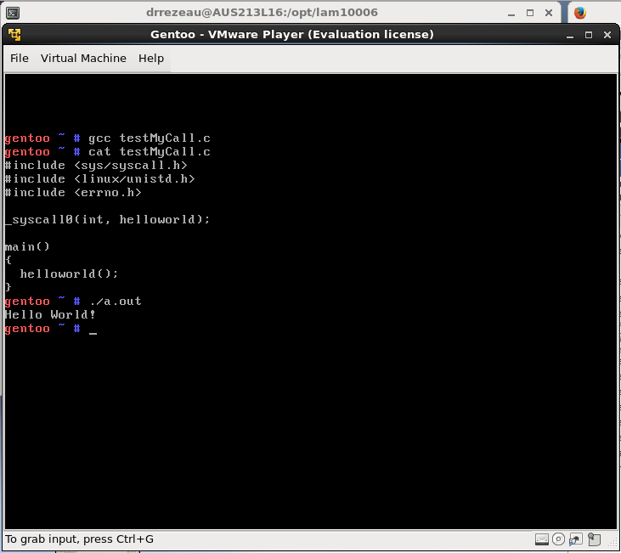

Part 2:

Doing part was a little harder, just since it was not explicitly spelled out for me. But using part 1 and the steps there I was able to get it working. When typing out the .c file, I missed a comma and spelled one thing wrong, so when I went to make it over I got a few errors. I was able to find them quickly though and fix them. After making the kernel and rebooting it, I was able to test my function and saw the output. I was successful at completing part 2 of the lab.

Before running the Test function

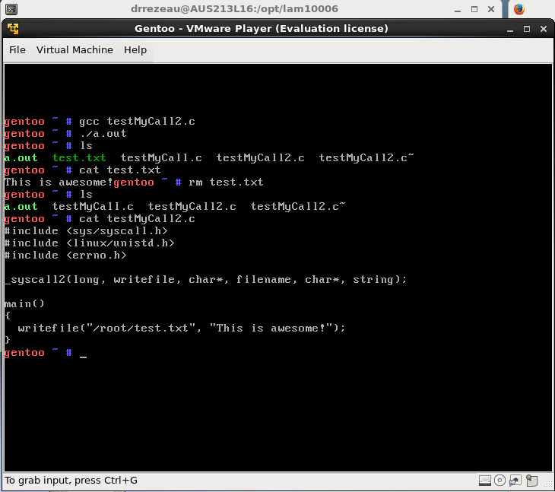

After Running test function

